**MESSENGER**

**WEB APPLICATION**

**Messenger is a messaging app and platform developed by Facebook.** **Users can send messages and exchange photos, videos, stickers, audio, and files, as well as react to other users' messages and interact with bots. This service also provides voice and video calling.**

**1.After opening the messenger website we need to log in to access our messenger app.**

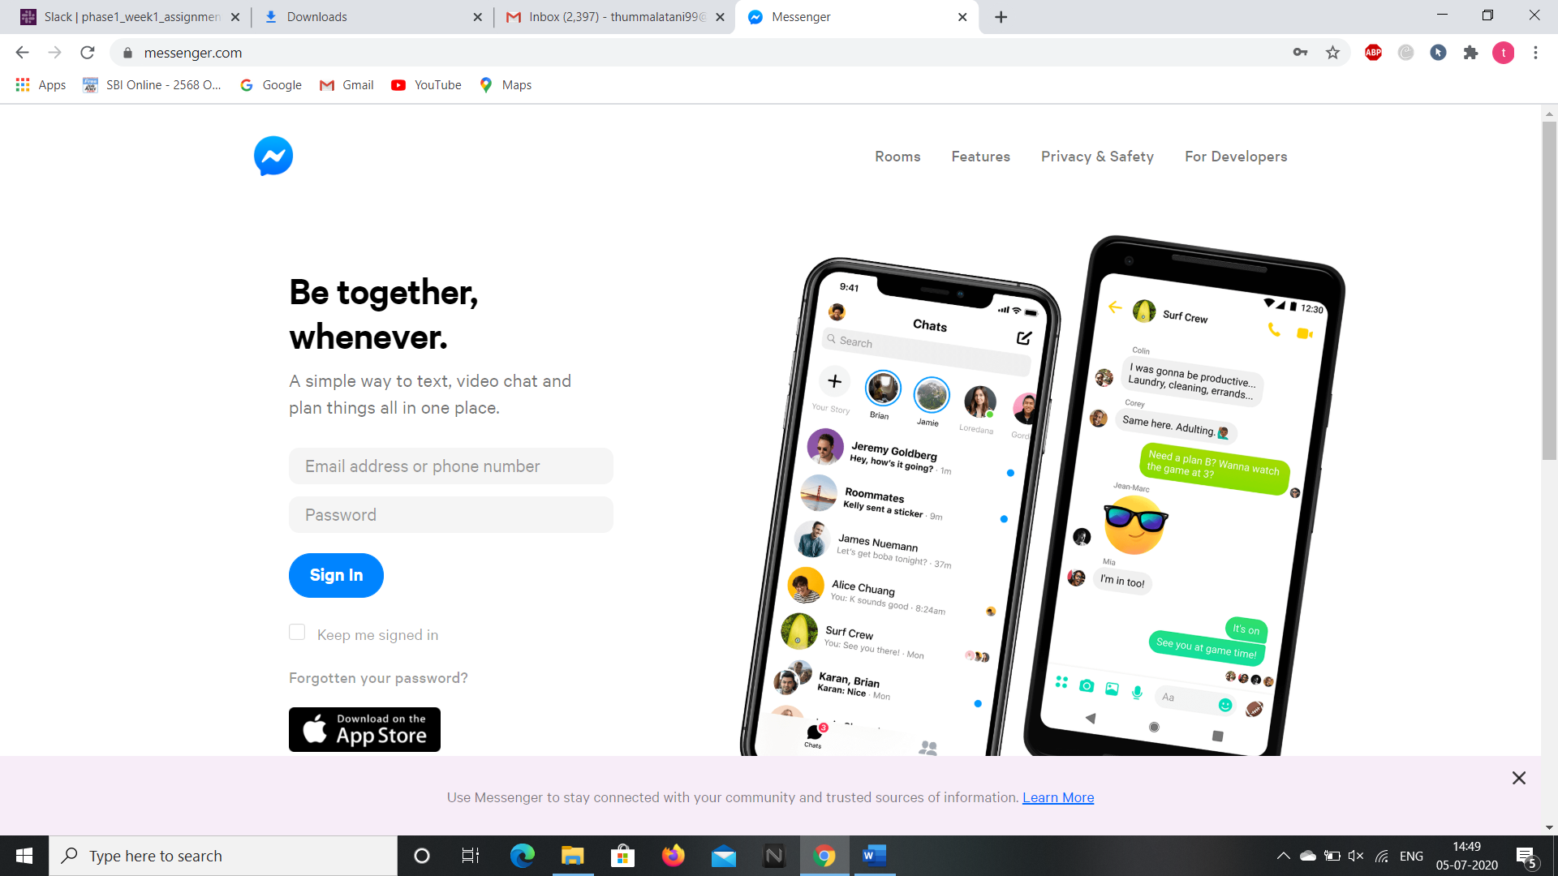

**2.We can access the messenger app only if we have a facebook account and by providing out email id and password we can open messenger web page.**

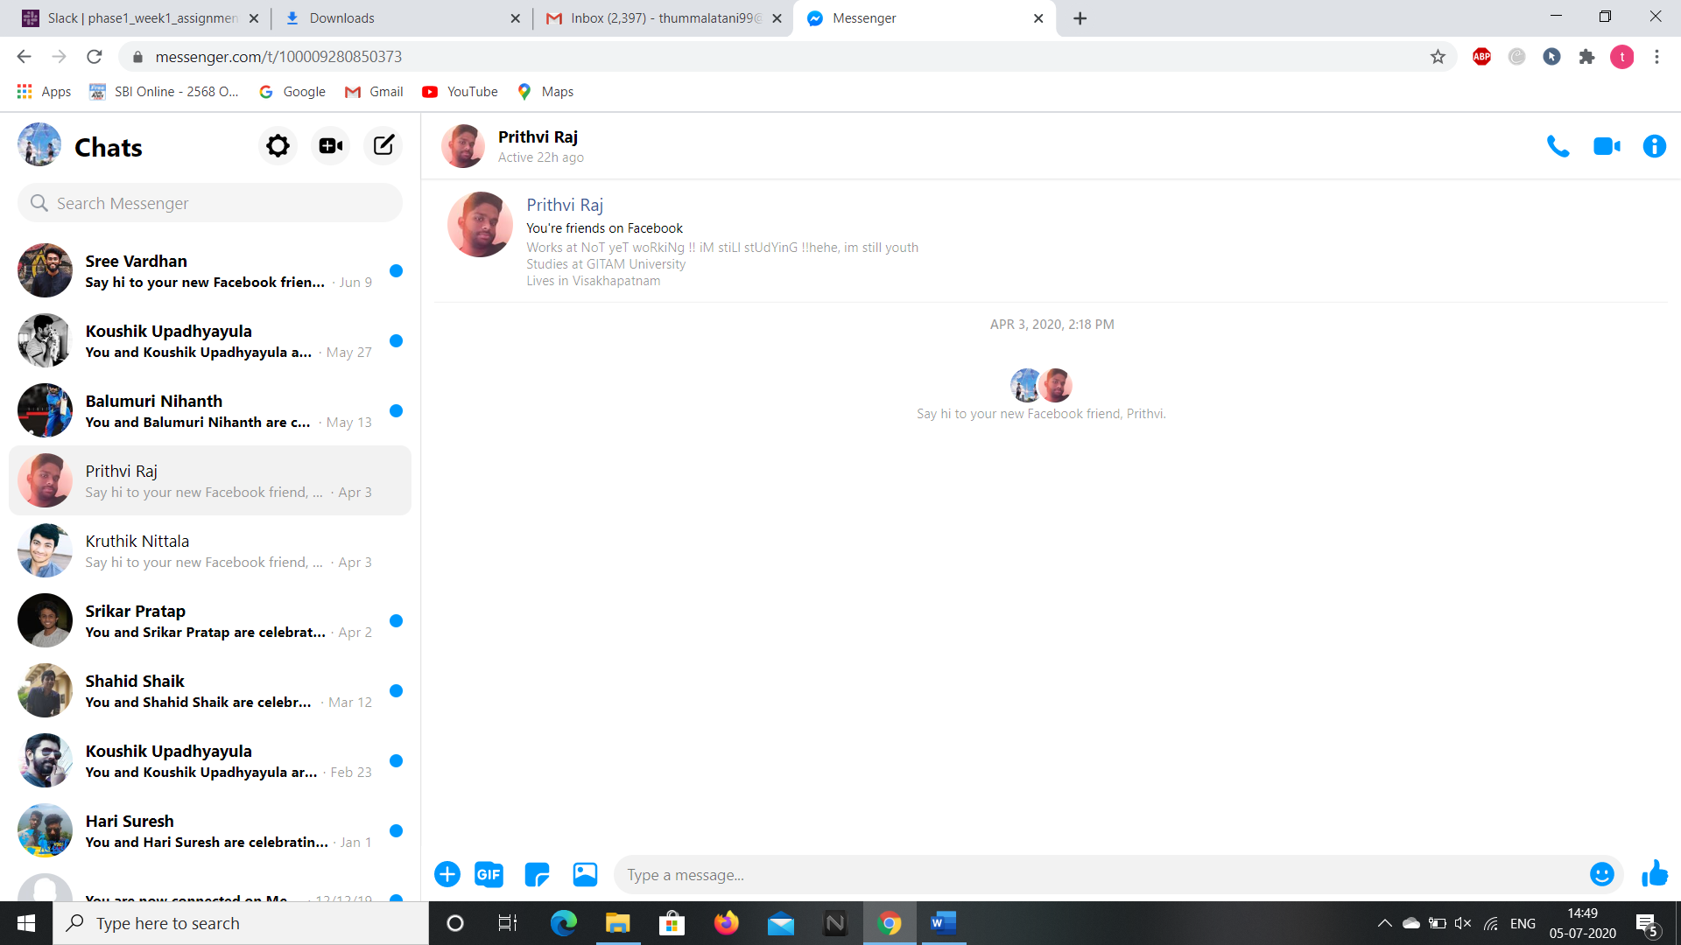

**From point 3 the privacy and secrecy details are shown so I have shown a tiny bit of images for better understanding.**

**3.We can create new rooms by clicking on the “+video” icon at the top left corner.**

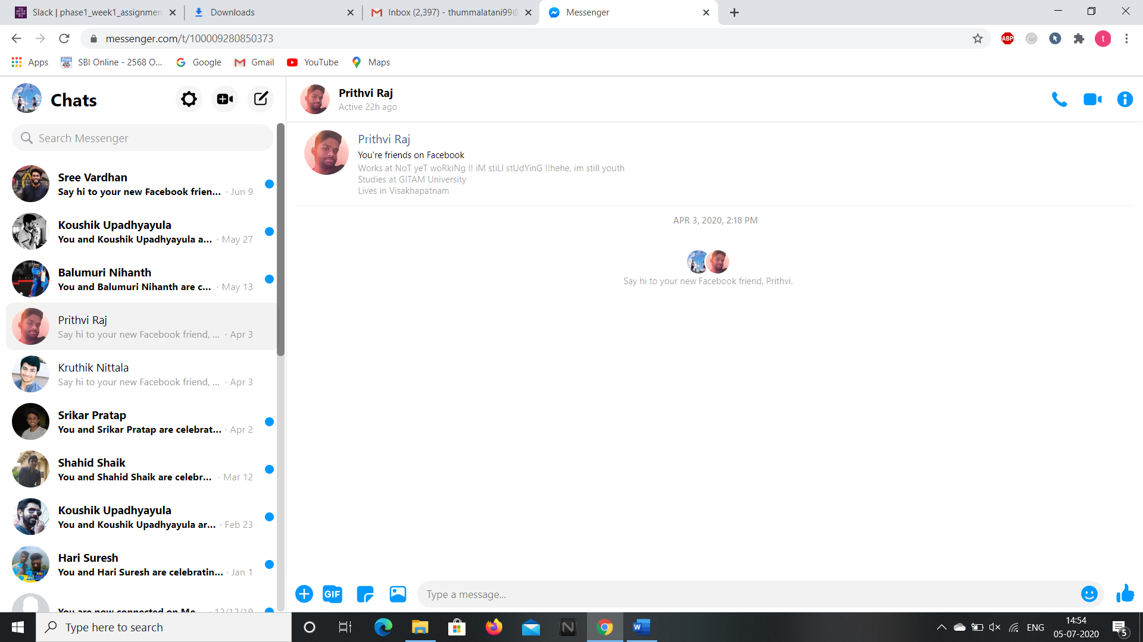

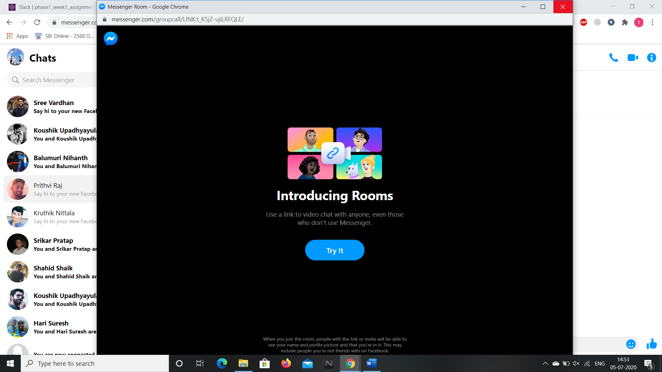

**4.We can access the settings, policy terms, and contacts by selecting “settings” icon at the top left corner.**

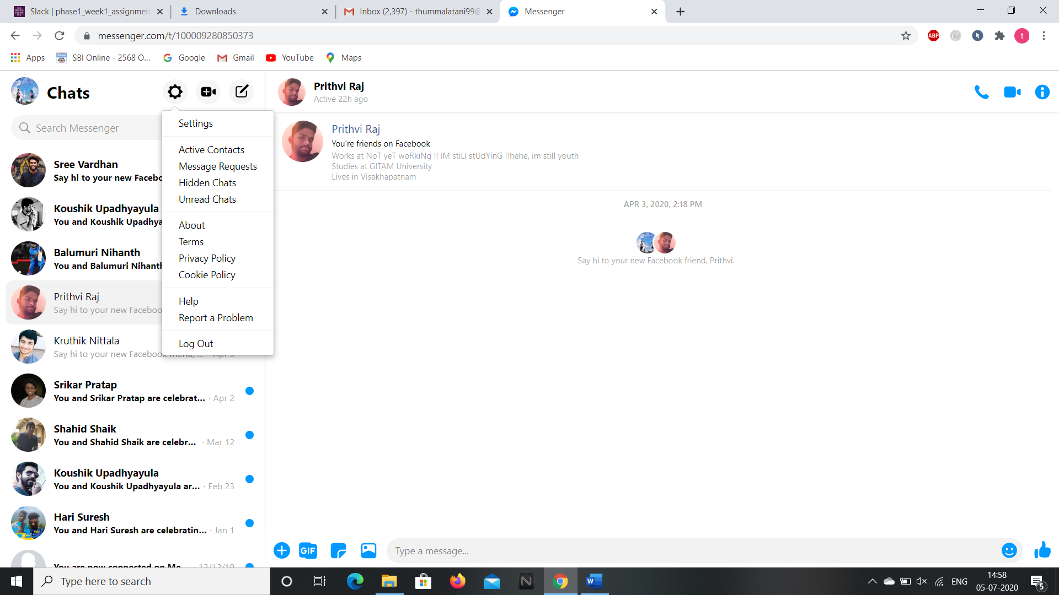

**5.We can send new message to a person by specifying the group name or person’s name by clicking on pencil icon.**

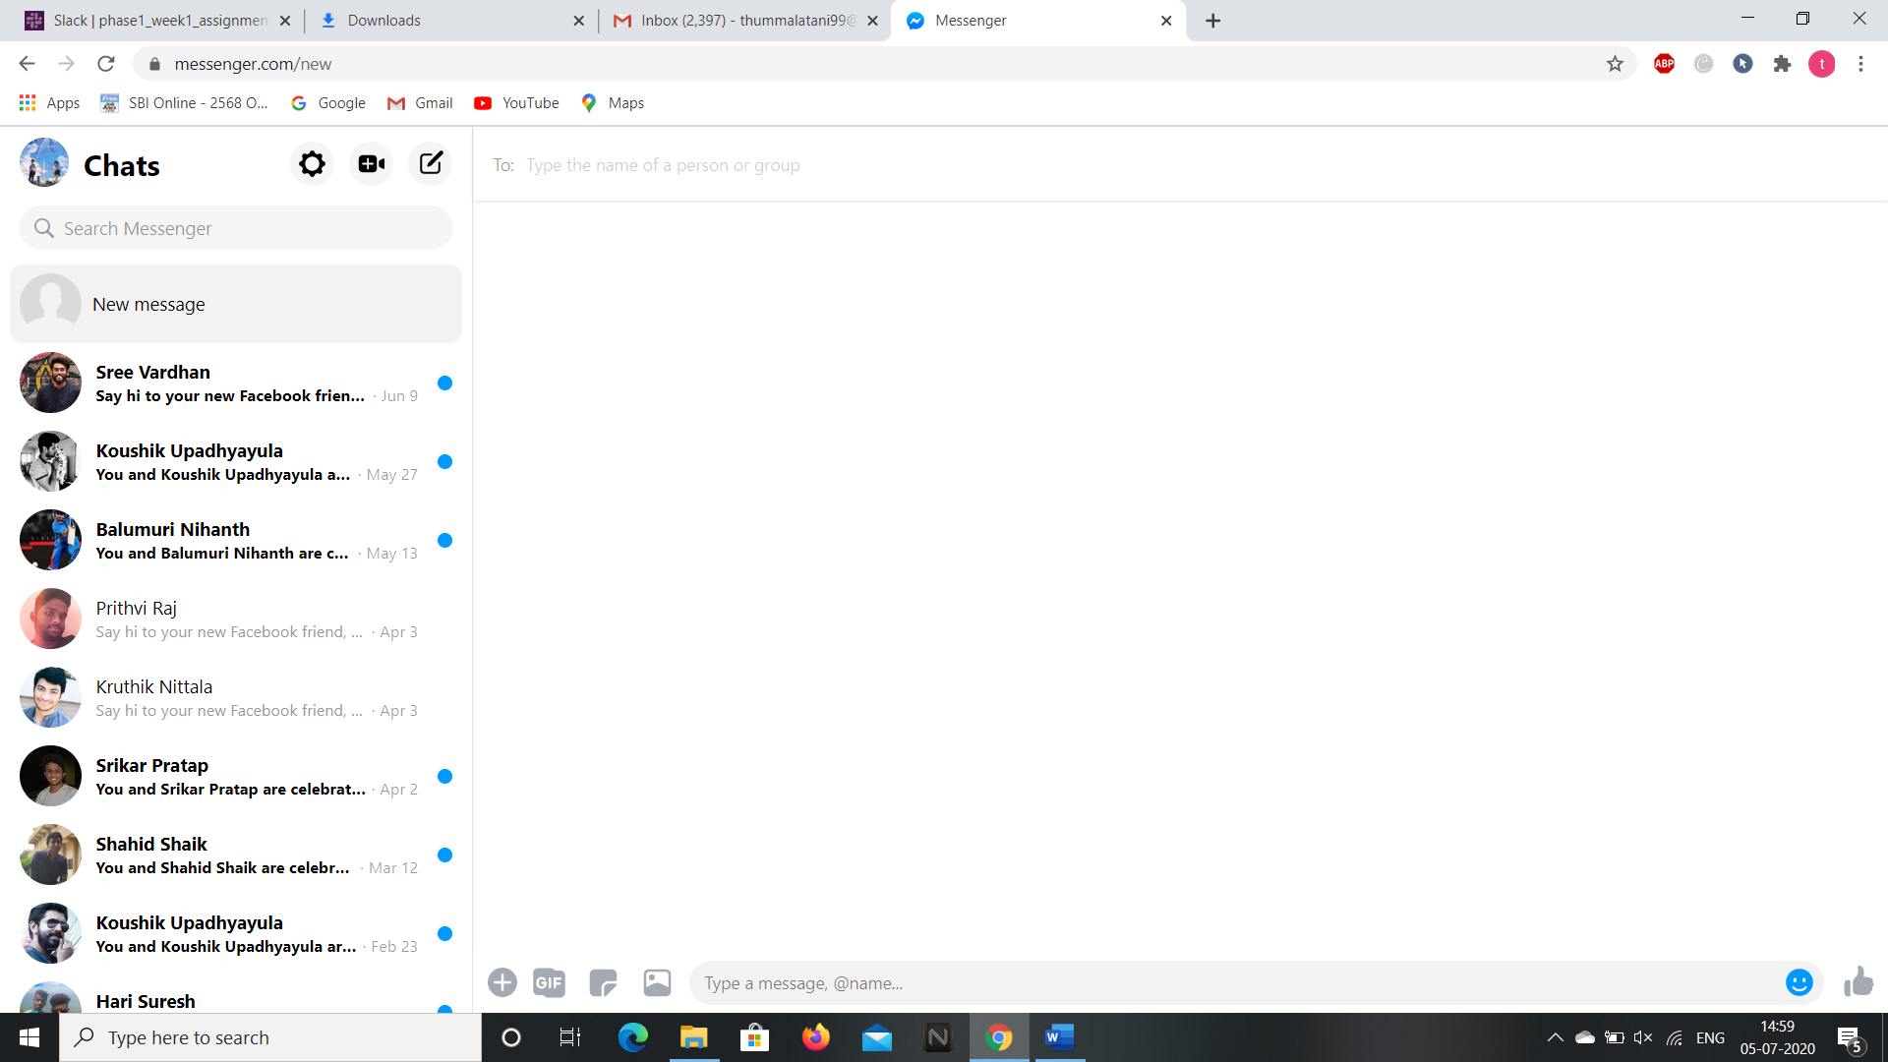

**6.We can search for our messenger through search box.**

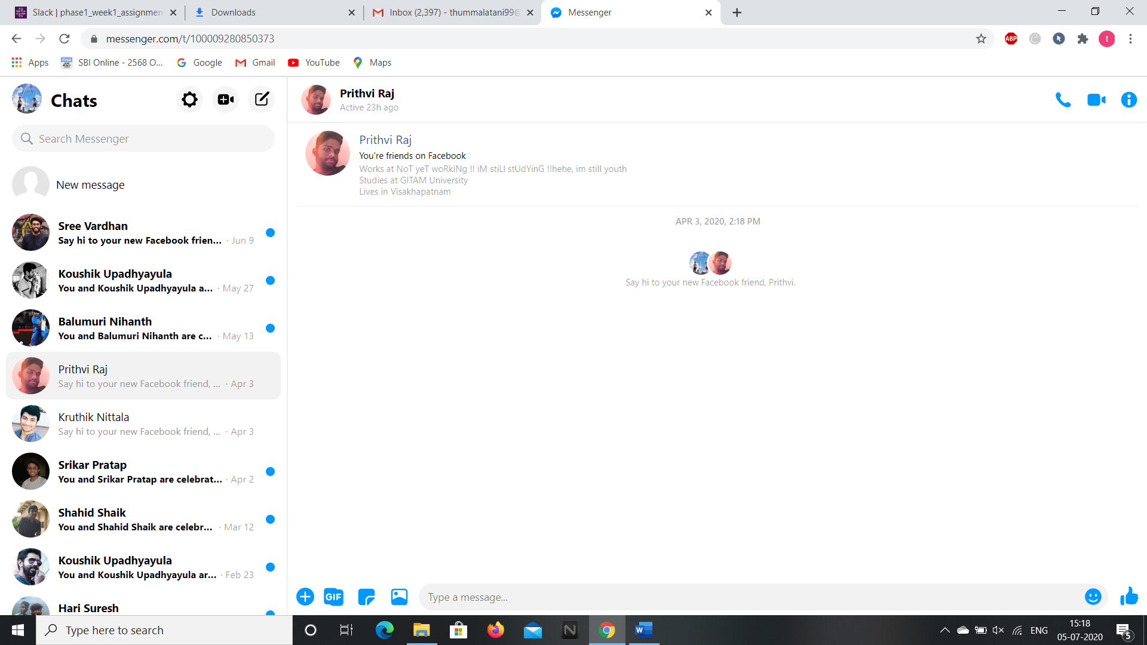

**7.We can start a call, video call and get conversation information through the below icons.**



**8.We can send an emoji by clicking on the emoji icon at the bottom left.**

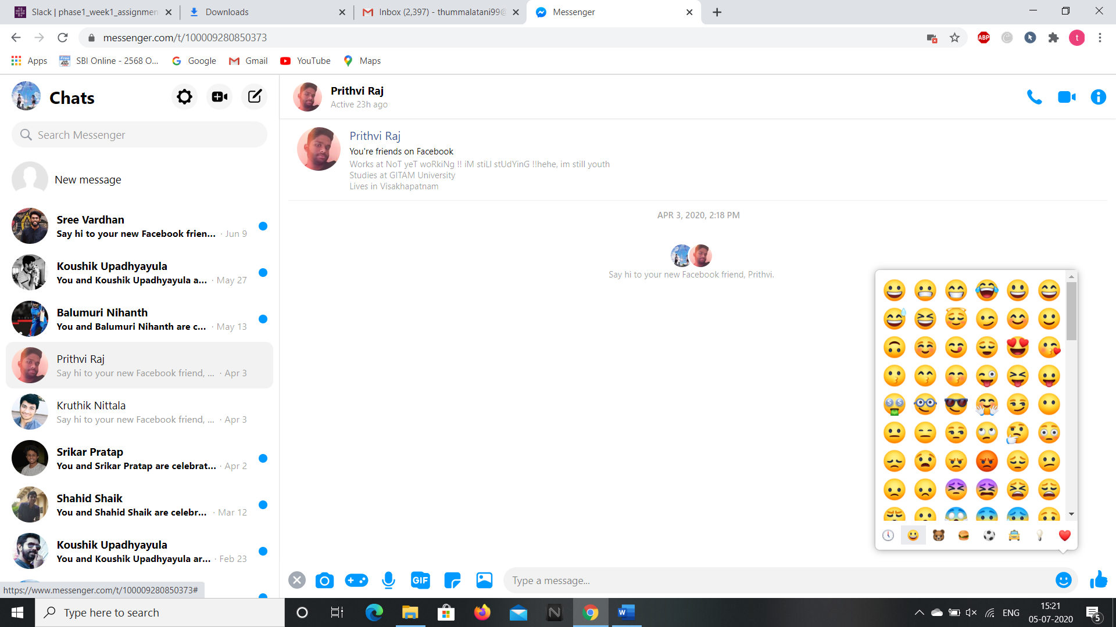

**9.We can send a like to the messenger by clicking the “Thumbs up” icon.**

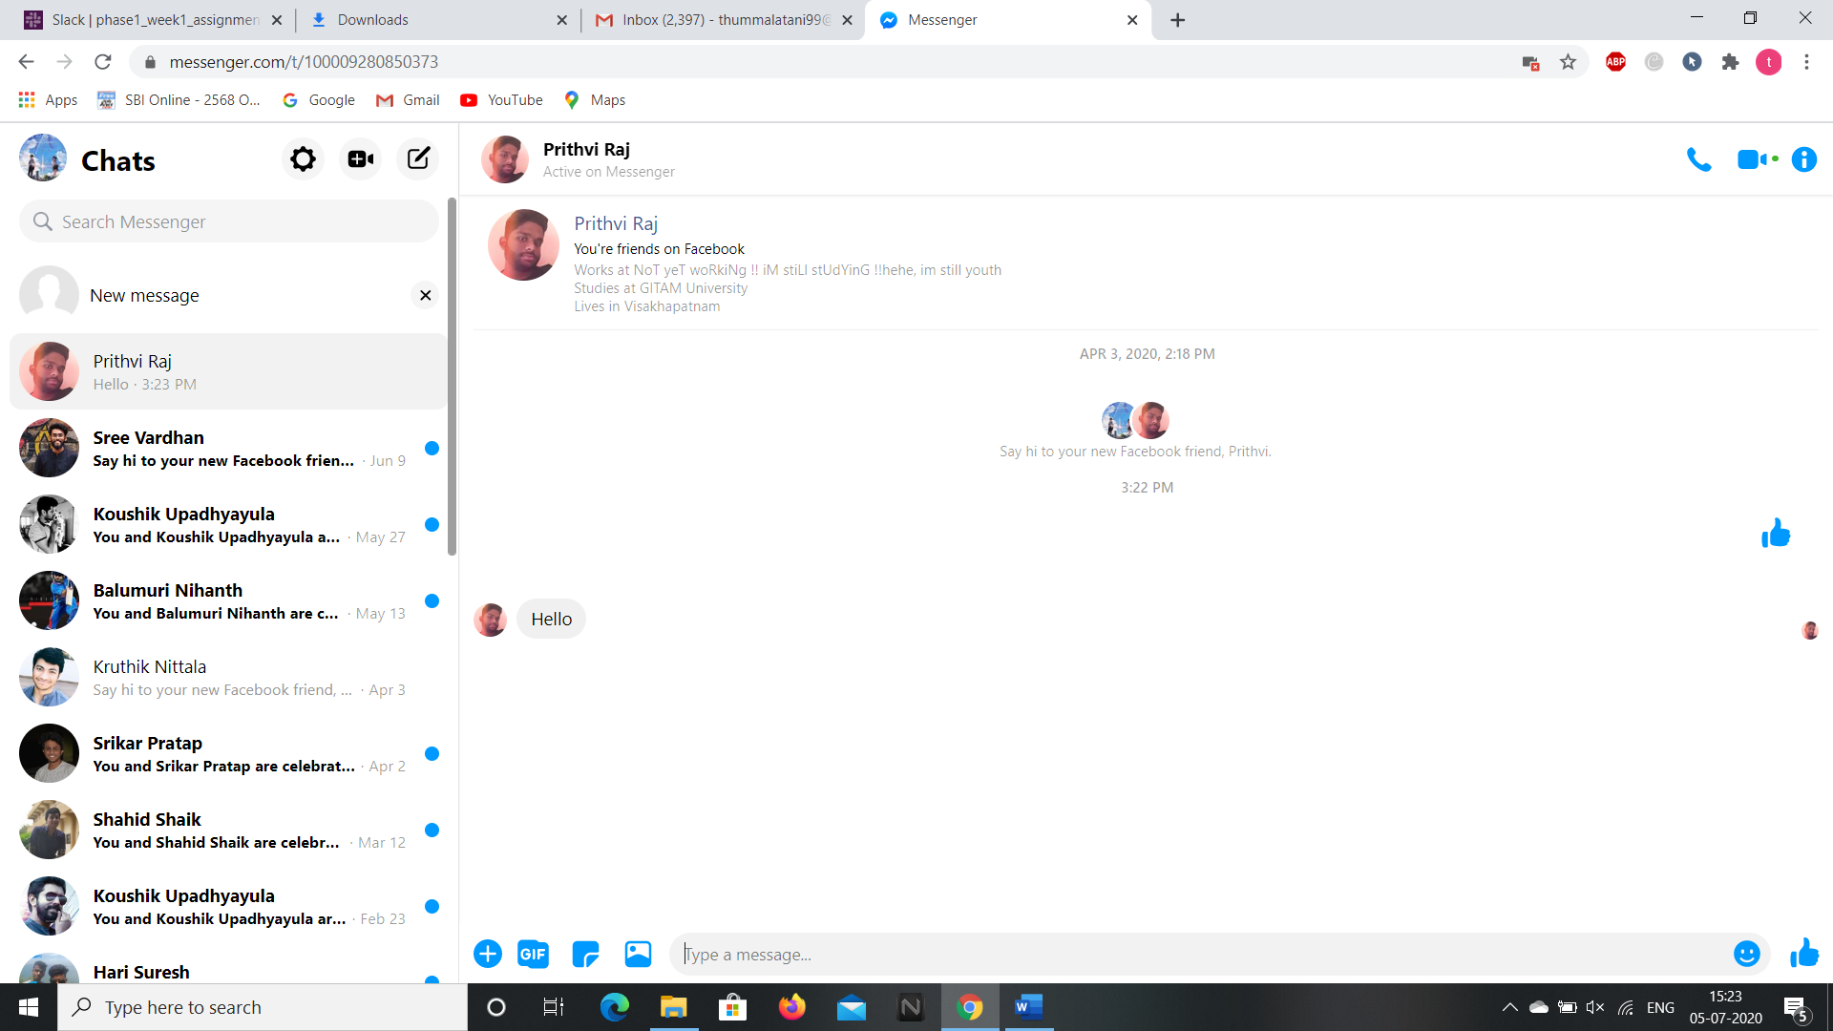

**10.We can send a GIFs to the messengers**

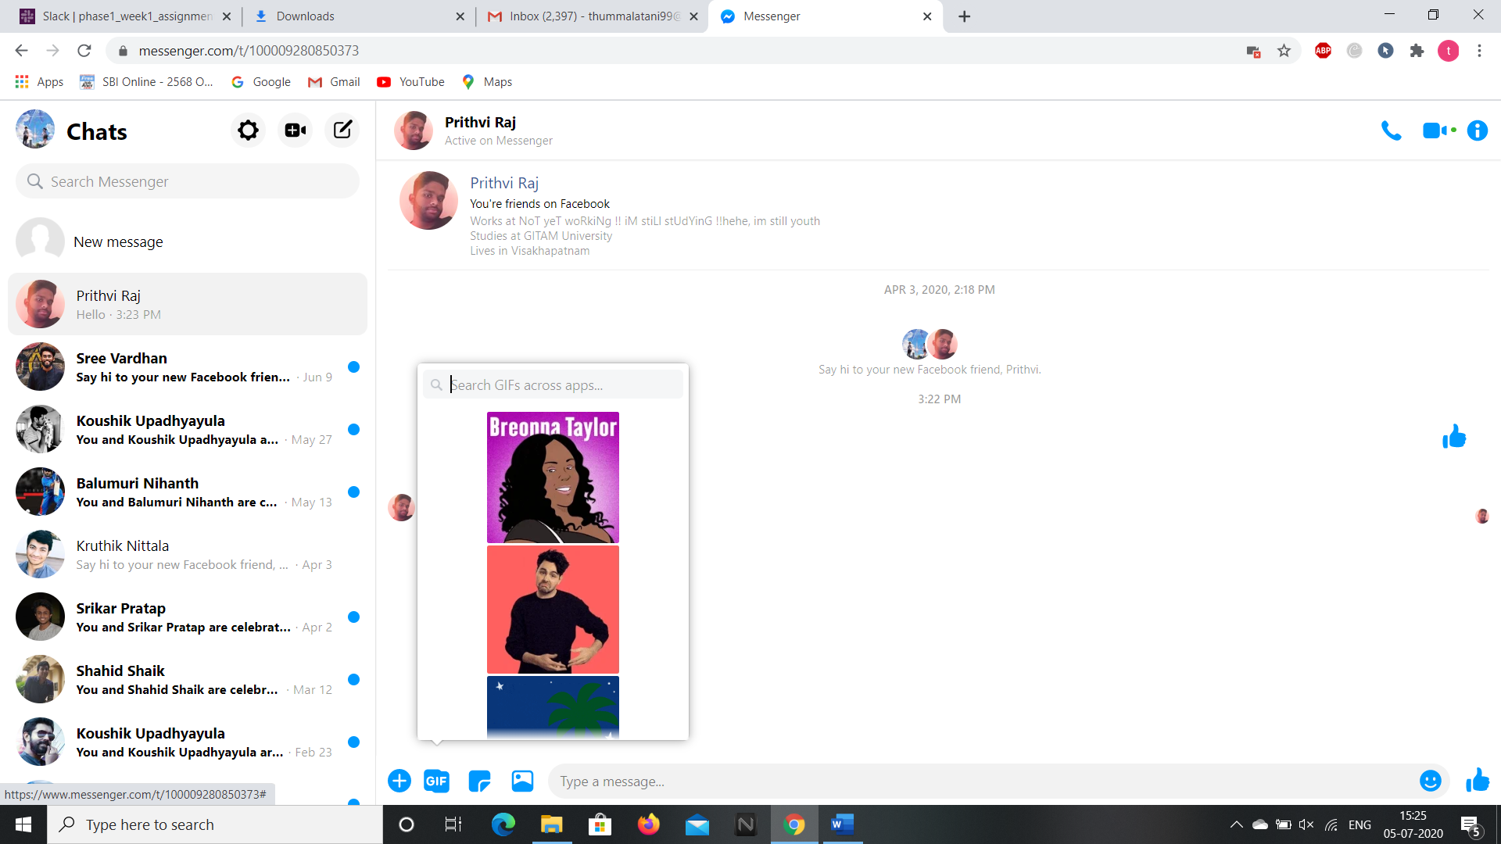

**11.We can send a sticker to the specified messenger.**

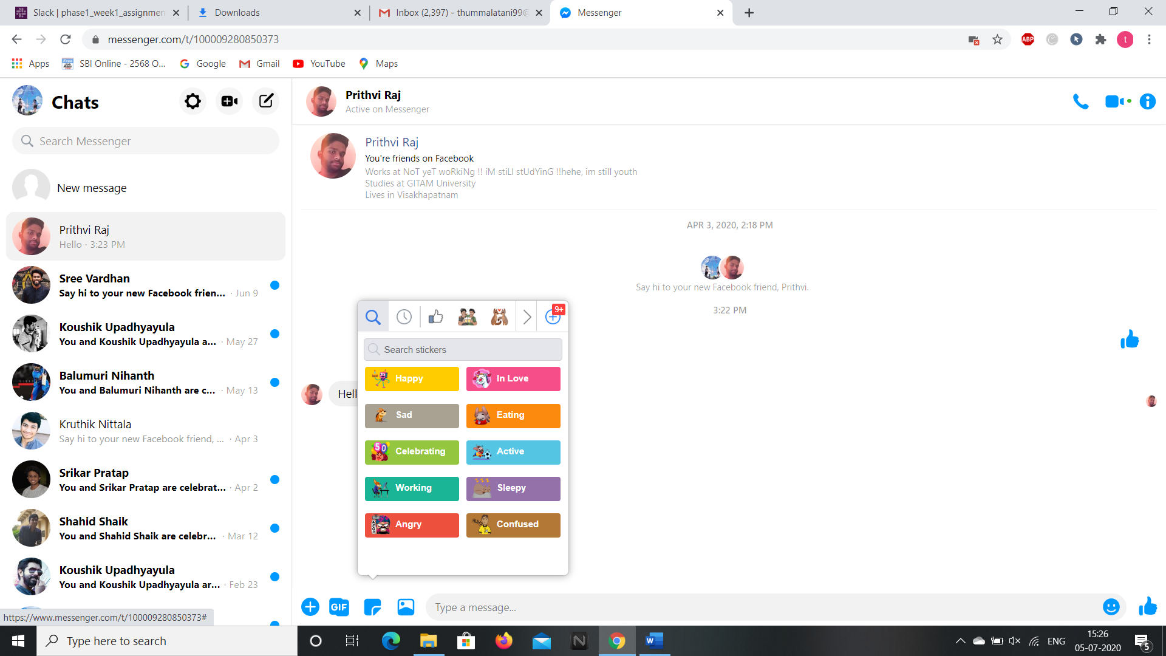

**13.We can send a picture by clicking on the picture icon button.**



**14.We can send a voice clip, play a game, send a photo through camera by clicking on the below icons after clicking on the plus button** 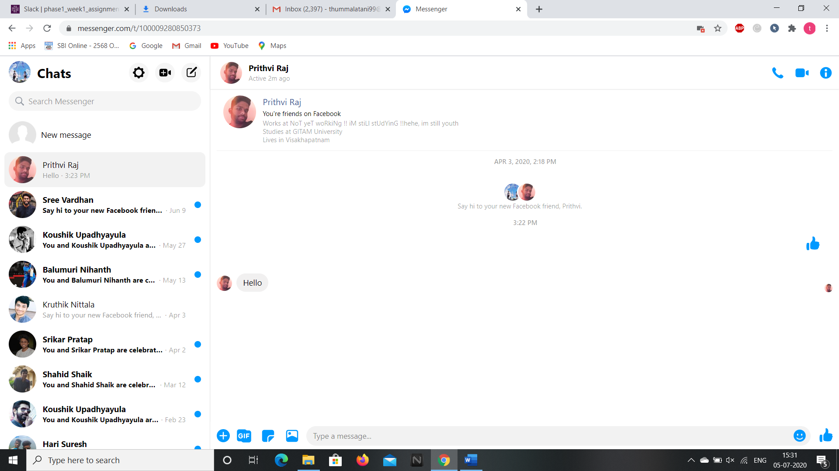.

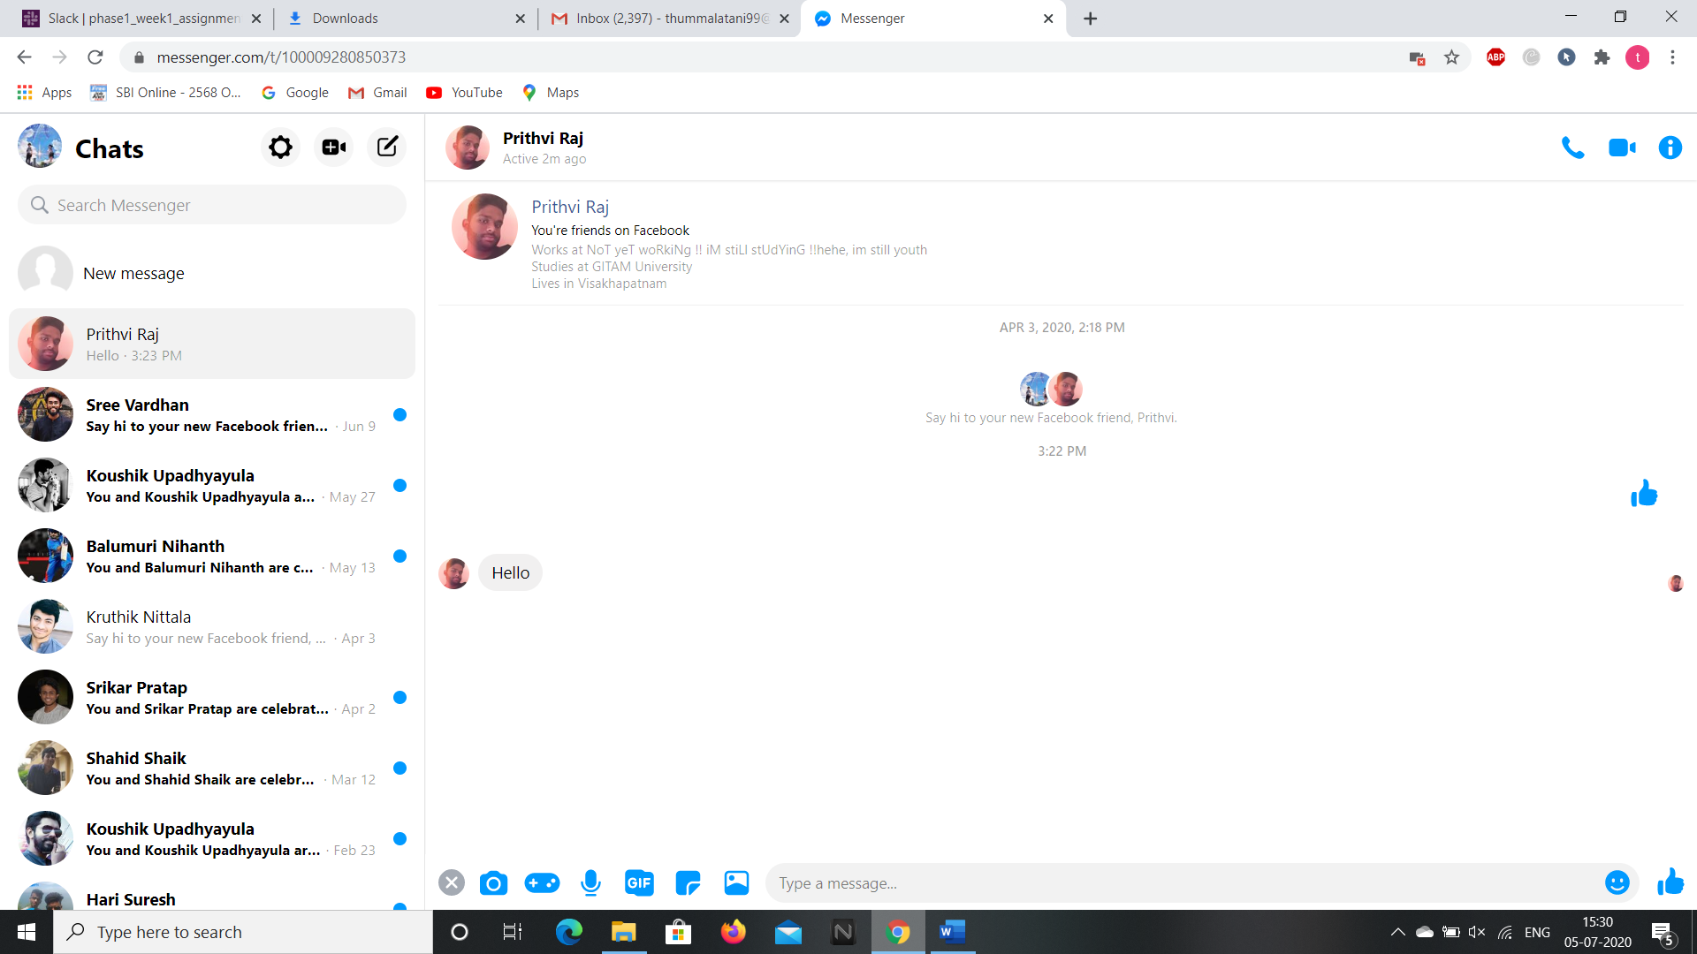

**So this is the way we can access the contents of this web application and we can access the webpage through selenium addon as well. Now, let’s see the android application of it.**

**ANDROID APPLICATION**

**We can download the android application through “Google Play Store” and installing it in the Virtual Phone through Android Studio.**

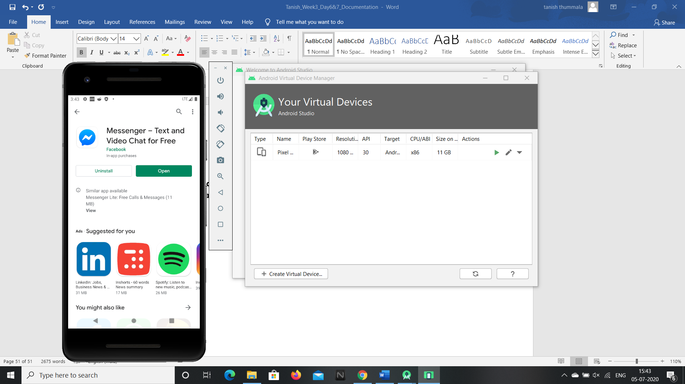

**1.After installing, open the app and login through our account or create a new account.**

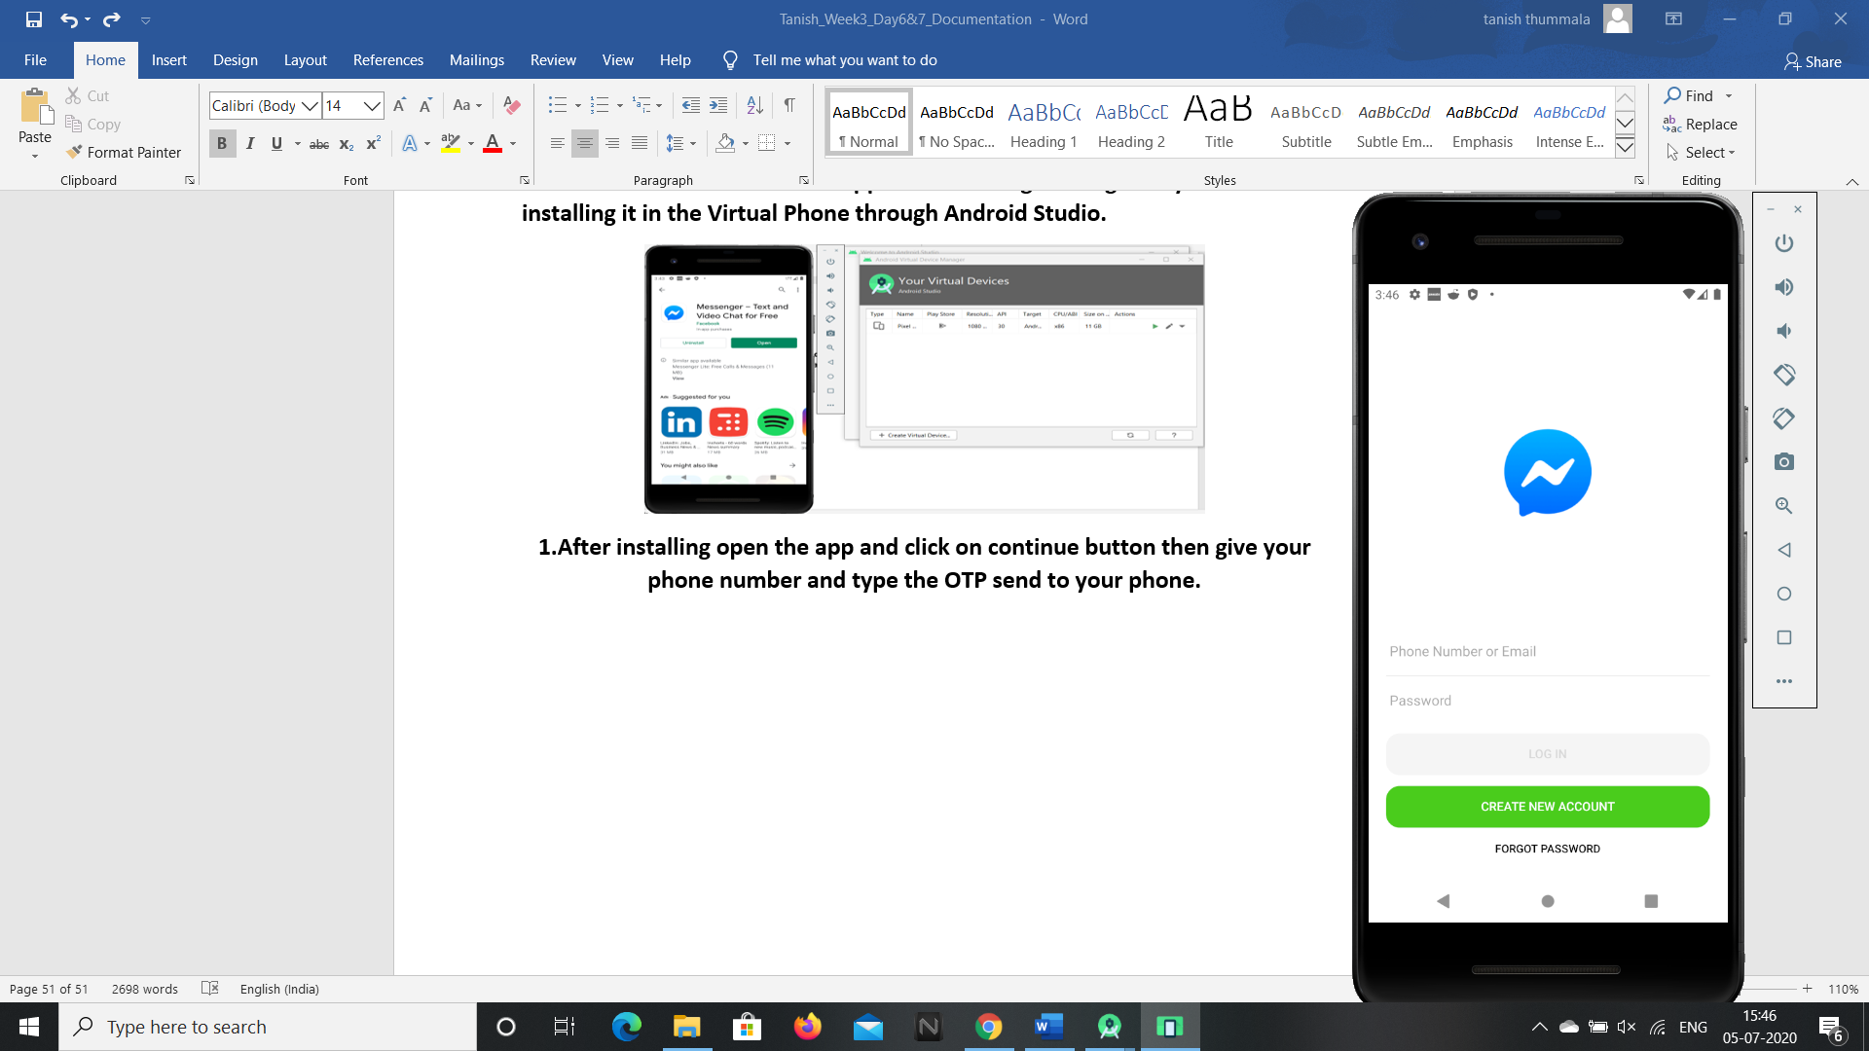

**From point 2 the privacy and secrecy details of the member is shown, so a tiny bit of images in android application is shown.**

**2.After logging in, messenger home page opens up and in the search box we can search for the specified messenger.**

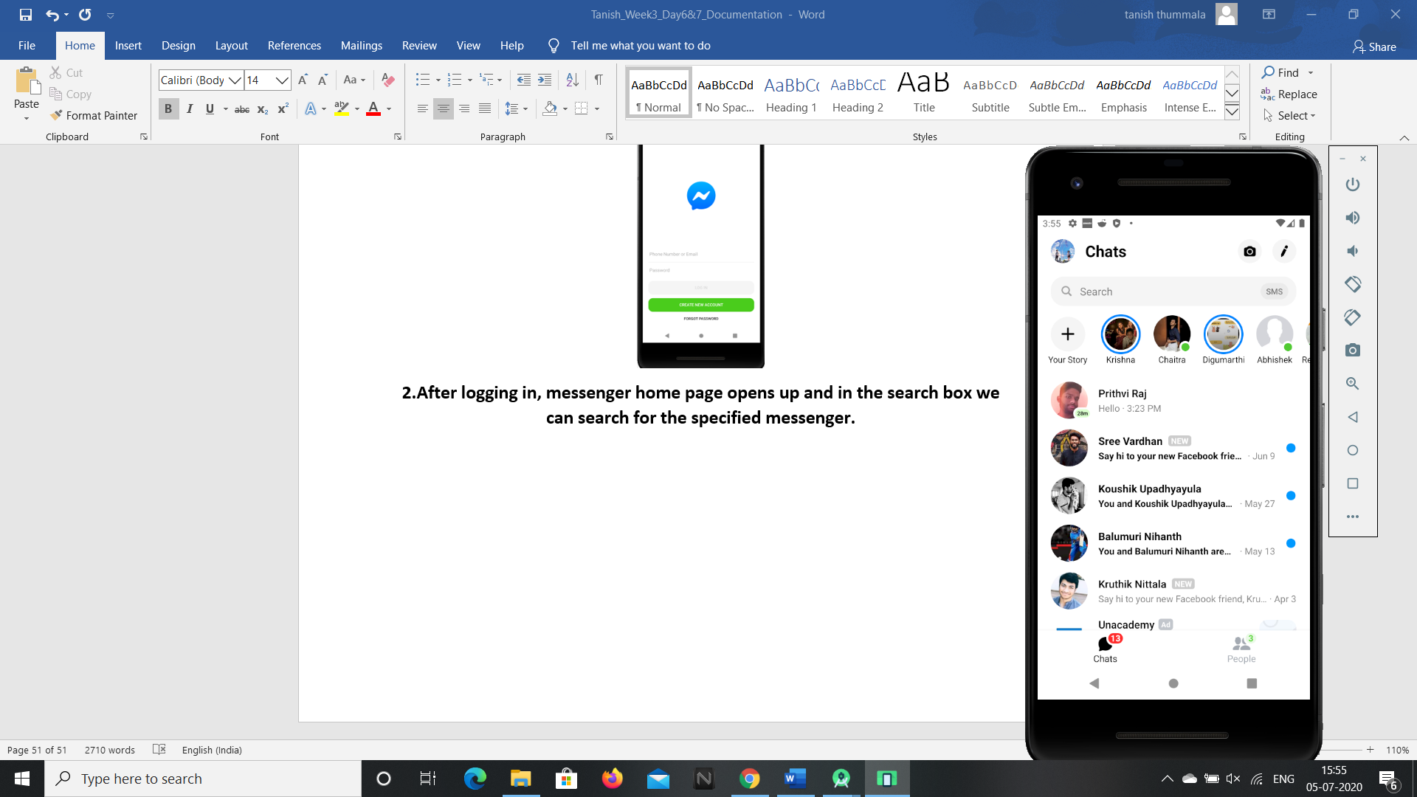

**3.We can check the stories and active rooms by clicking on the “people” icon.**

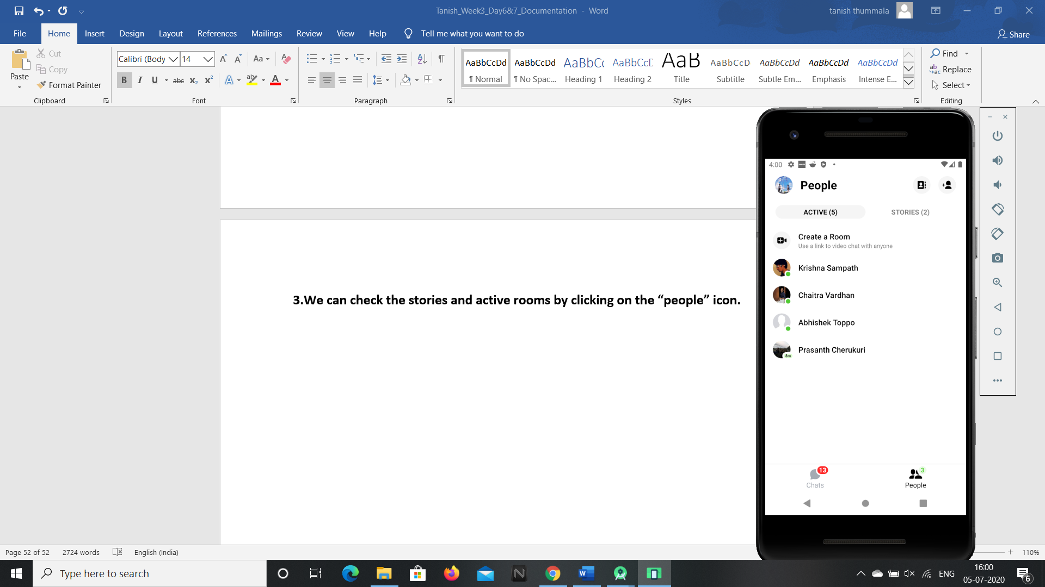

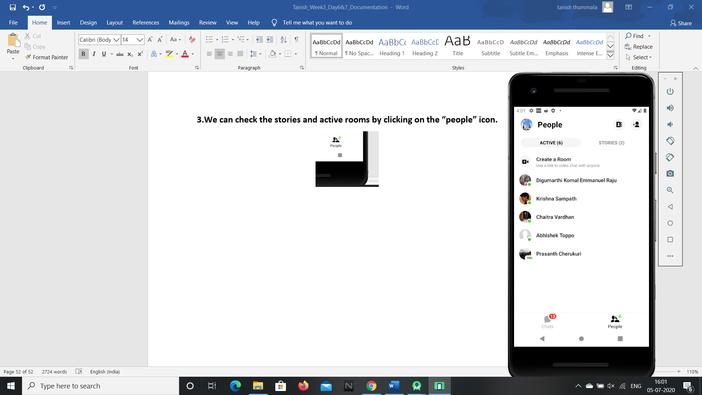

**4.We can send a video or photo by clicking on the camera icon at the top right corner in the chats page.**

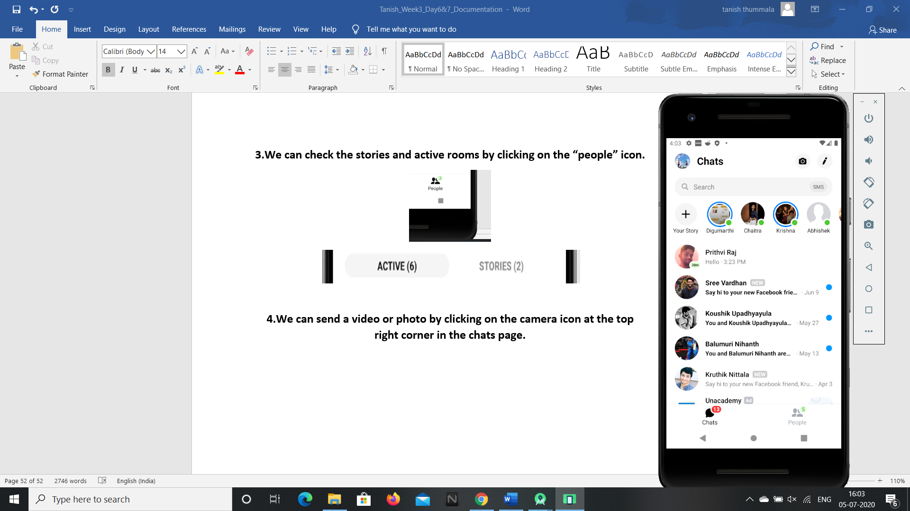

**5.We can send a message to the required people by specifying their name by clicking the edit icon button.**

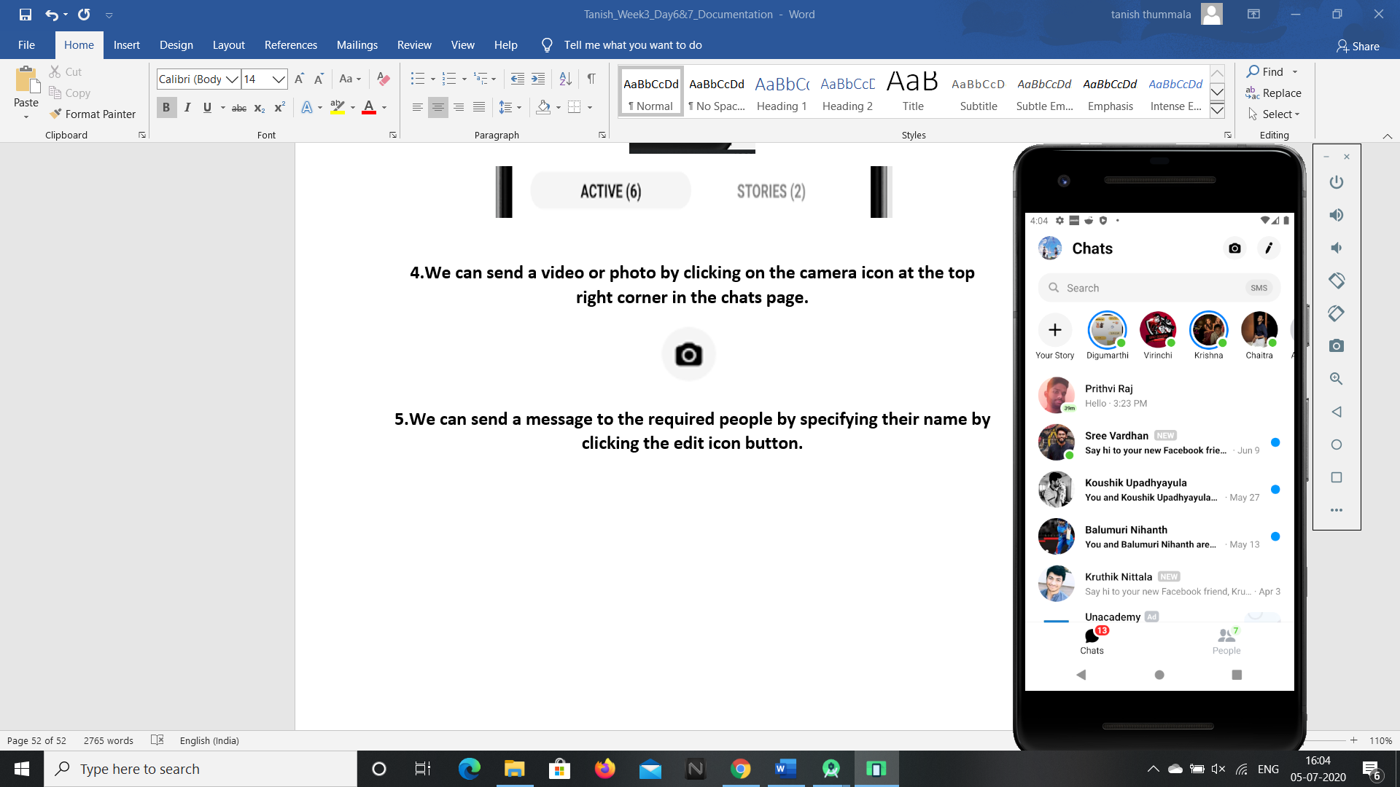

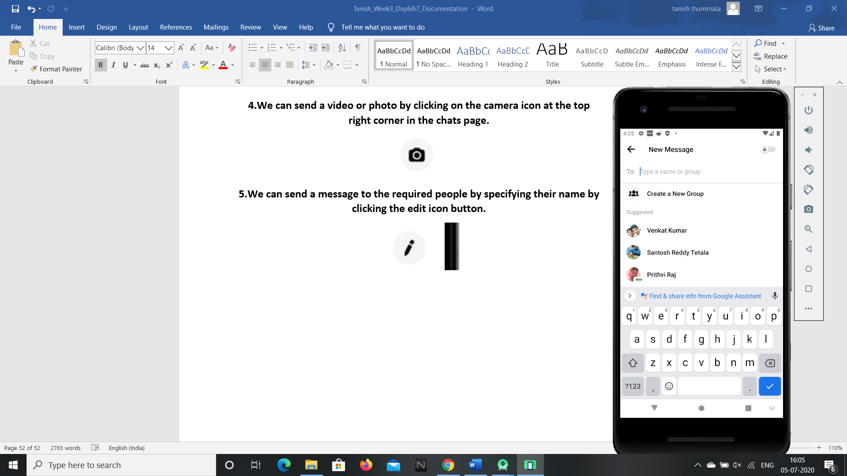

**6.We can find all the people related to us in the people page and clicking on the “Contacts” icon.**

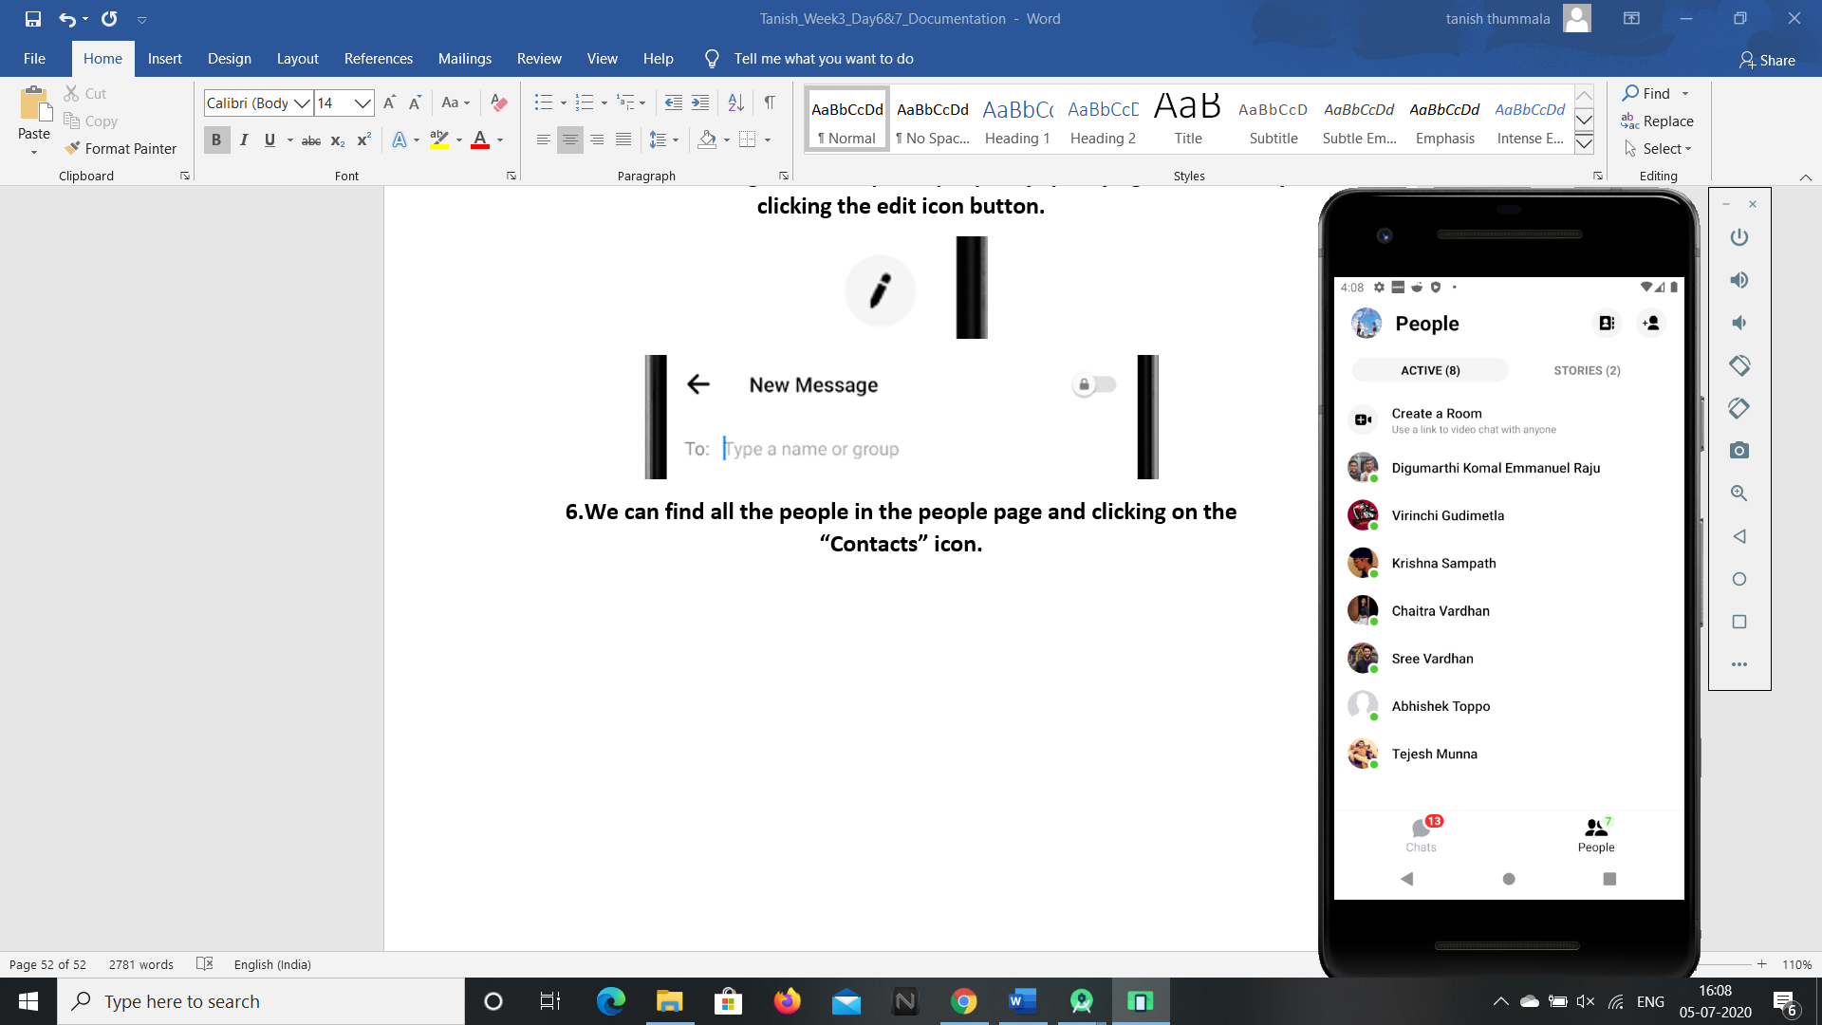

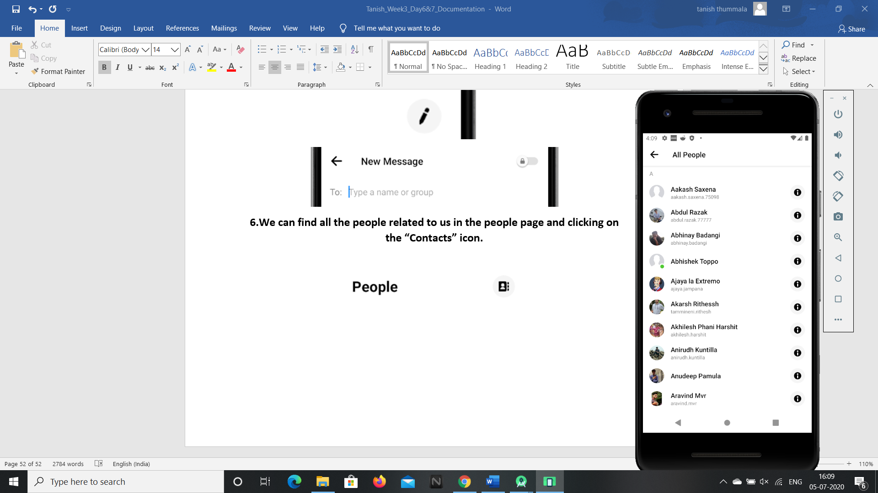

**7.To add contacts or to invite members click on the top right corner icon and we can add our required contact numbers with their details.**

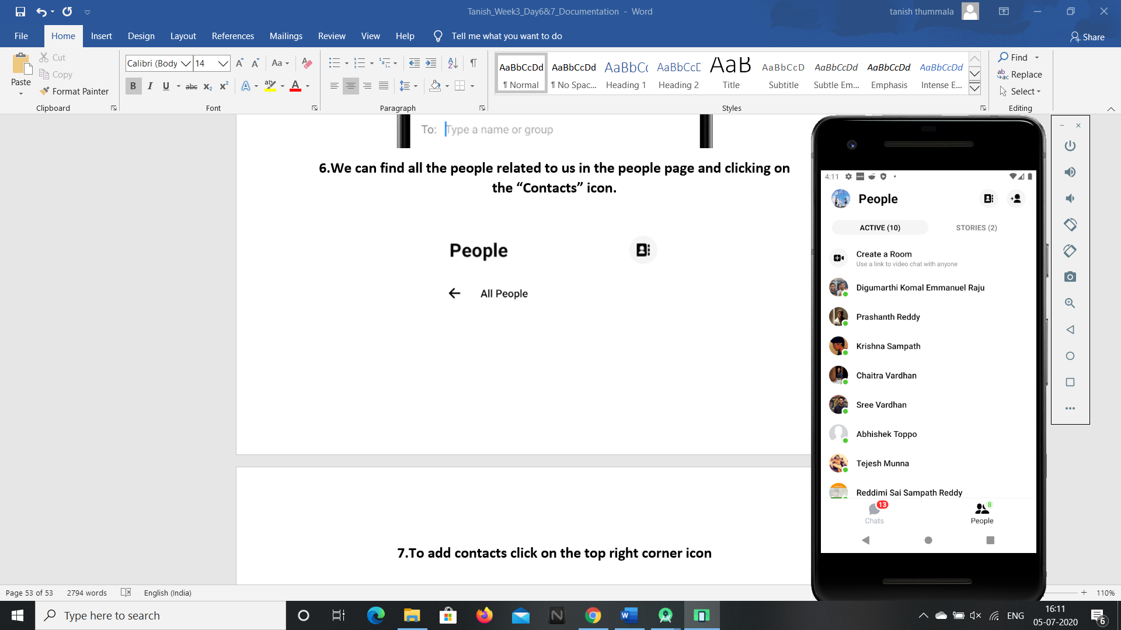

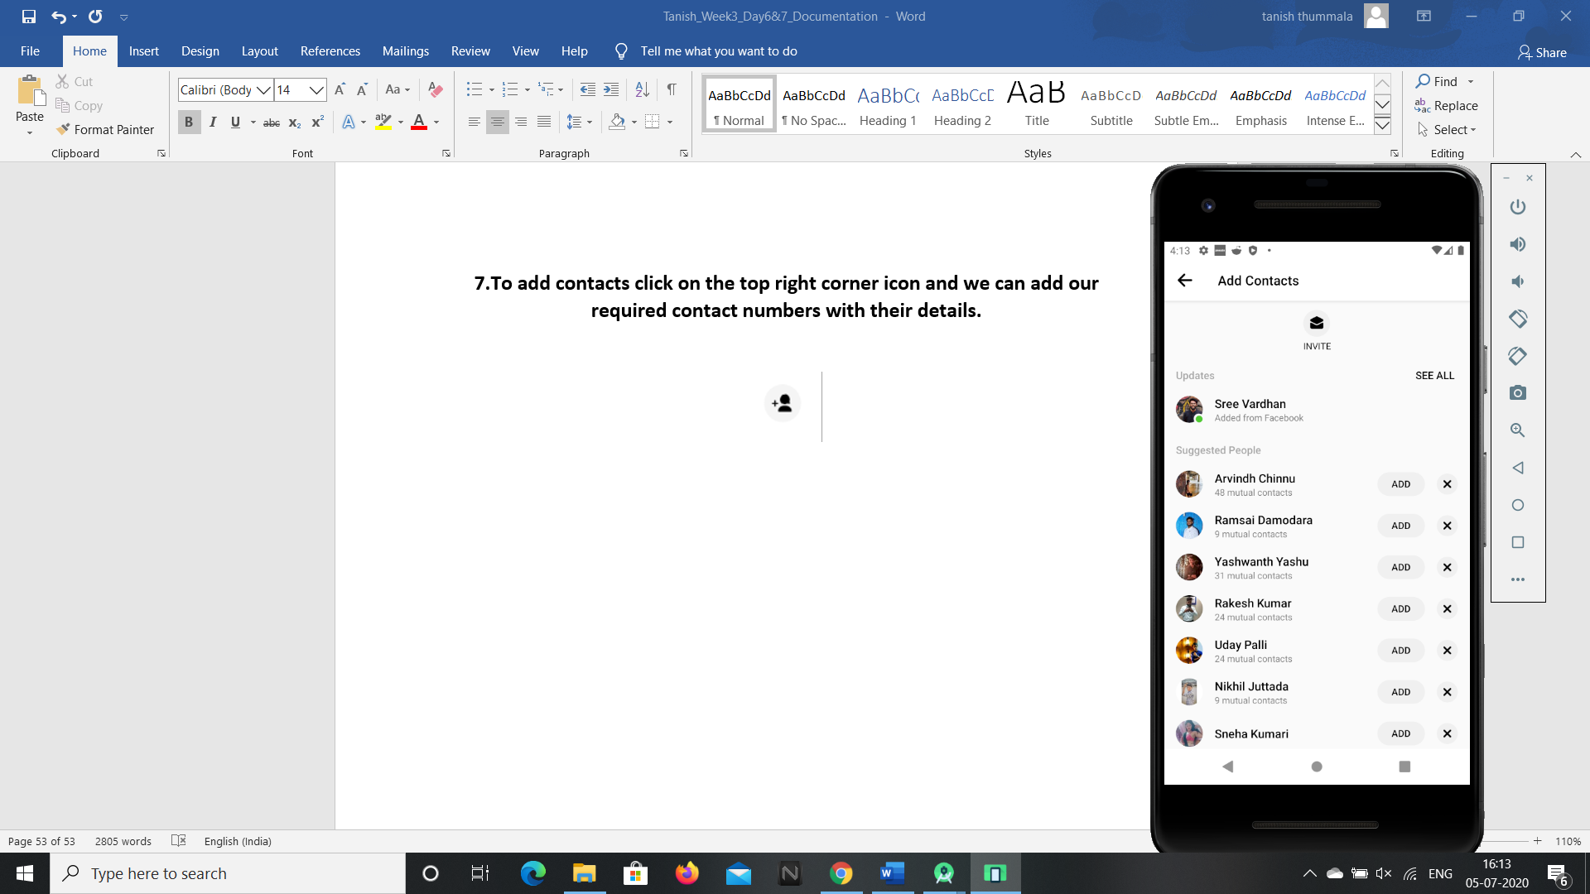

**So these are the features present in the messenger android application and these can be accessed by G1ANT Robot through Appium addon.**